“Developing communication, confidence and independence
for pupils with autism”

Curriculum Policy 2025

Introduction
Bradford Beacon School is an independent specialist day school for boys and girls aged 4 to 11 years and can accommodate up to 42 pupils. All pupils who attend Bradford Beacon School have a primary diagnosis of Autism and have an Educational Health Care Plan; EHCP. Our pupils may also present with additional complex needs such as ADHD, ADD, ODD, SEMH, Dyslexia, Dyscalculia and Dyspraxia and attachment difficulties. Pupil placements are from a range of local authorities including Bradford, Leeds and Wakefield.
We are proud to offer a comprehensive and dynamic curriculum. Three distinct pathways have been designed to cater to the diverse range of abilities and learning styles of our pupils, ensuring that every pupil can thrive and achieve their full potential.
Through our carefully crafted curriculum we offer a holistic and appropriate curriculum that fulfils pupils’ needs and interests. We aim to empower our pupils with the necessary knowledge, skills, and confidence to succeed in all aspects of life.
Our learning pathways ensure talents are nurtured, opportunities are experienced and that learning leads to positive outcomes that are right for each pupil.
Curriculum Intent
Curriculum Vision:
Our school provides pupils with a creative, flexible, personalised curriculum that helps to build their resilience, confidence and self-esteem. To fulfil the dreams and aspirations of all our learners and as outlined in each EHCP, our curriculum is delivered in a safe and supportive environment that celebrates both personal and academic achievement.
The Curriculum Policy provides the framework for effective teaching and learning at Bradford Beacon School. Our aims are influenced by the Equals Curriculum, the programmes of the National Curriculum and EYFS Development Matters.
The need for our curriculum to be flexible, adaptable and robust enough to meet the ever changing demands of the modern world and best prepare our pupils for a life within it, is the cornerstone of this policy.
Curriculum Rationale:
As a specialist independent school for pupils who have a wide range of needs and academic starting points, we strive to achieve a broad and balanced curriculum which is both reflective of the requirements of the National Curriculum programmes of study coupled with due regard to its duty to inclusion and equality as set out in the Special Educational Needs and Disability Code of Practice 2014 and Equality Act 2010. We ensure access to the curriculum areas that are listed in the Independent School Standards (2019).
Bradford Beacon School has adapted areas of the National Curriculum to meet the needs of pupils who have a diagnosis of Autism, with associated communication difficulties and language & social interaction difficulties. Our pupils are working significantly below age-related expectation and therefore require an appropriately tailored curriculum, with class groupings being identified by stage not age. The curriculum and teaching and learning approaches used are designed to reduce barriers to learning and ensure good progress and positive engagement. We place a high priority on Personal, Social, Health and Economic (PSHE) Education to maximise opportunities for personal autonomy and to enhance quality of life.
Our school environment supports inquisitive minds with areas that offer purposeful break out, sensory and individual learning spaces. Learning experiences happen both formally and informally within a lesson or outside of the classroom, throughout the whole school day with continuous therapeutic input, supporting social and emotional well-being. Our pupils learn best when teaching approaches allow for generalisation and concentrate on real-life situations rather than abstract concepts. We recognise that many of our pupils have very specific difficulties but believe that compassion, tolerance and positive intervention effect change.
At Bradford Beacon School we coordinate a collaborative approach to our curriculum. Teachers, support staff, clinical professionals including Speech and Language and Occupational Therapists and all other staff structure and support experiences to ensure that they have the most positive effect on the attainment, progress and personal development of all pupils.
The Curriculum Policy is intended to sit alongside other school policies and is used to drive standards, attainment and provision for the pupils at Bradford Beacon School. All staff have a responsibility to uphold the policy, and the Head of School, Deputy Headteacher, SENCO and teaching staff have key responsibilities within this.
Curriculum Aims:
At Bradford Beacon School, we are committed to providing a nurturing and inclusive environment where every child can thrive. The need for our curriculum to be flexible, adaptable and robust enough to meet the ever-changing demands of the modern world, and best prepare our pupils for a life within it, is the cornerstone of this policy.
Our curriculum is designed to meet the diverse needs of our learners, fostering independence, social skills, and a love for learning through our tailored curriculum pathways. We will;
- Create enabling environments that promote the wellbeing of each individual pupil in a safe and secure setting.
- Prioritise development of basic life skills and greater independence, including communication, self-care and social interactions.
- Focus on the whole child, developing self-confidence, and capacity for emotional regulation, communication, pride in themselves and the interest to learn.
- Create a stimulating learning environment that encourages engagement through hands-on activities, sensory experiences, and real-life contexts to motivate and inspire learners.
- Foster collaboration among pupils, staff, and families to create a strong sense of community, supporting pupils in building relationships and social skills. Enabling self-awareness and an understanding of their community and the world they live in.
- Ensure all learners feel valued and included by using adaptive teaching strategies and resources that accommodate diverse learning styles and needs. We aim to provide explicit instructions and sufficient time for learners to repeat, practice, maintain and consolidate the skills to develop independence.
- Celebrate each child's achievements and instil a passion for lifelong learning, by developing curiosity and resilience, encouraging pupils to explore their interests and potential beyond the classroom.
- Unlock the potential of the learners at Bradford Beacon School so they can start their journey to a fulfilling life.
Our curriculum aims to address the barriers to learning which our pupils experience as a result of their autism, additional diagnoses, or past experiences. Given the diversity of needs and strengths across our pupil population, we aim to establish and sustain the very highest standards of teaching and learning so that gaps and specific areas of challenge can be addressed and overcome. The following factors will enable us to do this.
- The Environment.
The physical environment and the resources within it is carefully designed and managed to actively contribute to pupils’ learning, recognising the need for specialist spaces such as break-out spaces, therapeutic and sensory spaces. We aim to provide a therapeutic, supportive and nurturing environment for everyone.

- Our Expectations.
The level, type and volume of work in any activity or lesson is specifically tuned to the needs and abilities of individual learners. Expectations placed on pupils must build on their previous experiences and promote the highest possible level of progress.

- Pupil Experience.
Engagement is key to successful learning and our curriculum, therefore, its foundation is based on the personal wellbeing and involvement of all pupils.
Our aim is not only to help our pupils to acquire knowledge and skills but to ensure they can generalise and apply these across a range of settings and situations. Above all, we are committed to helping every pupil leave Bradford Beacon School with the highest possible level of independence and autonomy, whether that means managing sensory and emotional needs, making informed choices, communicating effectively or confidently pursuing personal interests and life goals.
Curriculum Implementation
We have segmented our curriculum into three Pathways to encompass all pupils learning journeys reflecting needs. It is key to note that every child’s learning journey is different and as a school we have varied expectations of progress dependent on the individual child’s needs. At Bradford Beacon School, we recognise that all pupils will need to develop core communication and interaction skills, learn how to manage their physical and sensory needs, impacting positively on their social, emotional, and mental health before they are able to immerse themselves in the wider demands of the curriculum and learning.
Pupils are assessed as and when referred. Using a multi-disciplinary approach, we will map out their curriculum using a pathway that best suits their needs at that moment in time. This will be reviewed every term, and the pathways are made fluid so that a pupil can move between pathways reflective of needs.
In order to ensure that pupils are accessing the pathway that is appropriate to their needs, we assess informally around the time of referral by making visits to the young person, speaking with current and previous education placements regarding current curriculum access/offer and progress, and by reviewing the current EHCP. Alongside this, we would discuss their needs with parents and carers to gauge how they would be best placed within school.
The school’s teaching spaces are nurturing in nature and create a safe and positive environment for pupils. Classrooms have a maximum of 6 pupils per class supported by a teacher and two teaching assistants, enabling staff and pupils to build trusting relationships and establish routines and consistency. There is access to additional spaces such as breakout rooms and specialist areas including immersion room, soft play and therapy spaces.
The curriculum offer at Bradford Beacon School is pupil centred and positions the pupil’s EHCP outcomes at its core. This ensures every pupil has access to a curriculum, pedagogy and provision that is tailored to their specific needs, interests, and talents. Each pupil at Bradford Beacon School will have their own Personalised Learning Intention (PLI) plan.
Offering three interconnected pathways from EYFS to Year 6: Pathway 1; Informal, Pathway 2; Semi-formal, Pathway 3; Formal; pupils receive a highly differentiated curriculum offer which is aligned with their individual needs by:
- Focussing on meeting the specific learning needs of all pupils with clear focus and broad content to the delivery of a quality education to all.
- Developing key basic skills whether academic and/or functional, as appropriate to each pupil.
- Building progressive core knowledge and key concepts using a range of learning skills and subject skills. Leading to pupils being able to recall and communicate knowledge, skills and concepts acquired in familiar, unfamiliar, local and global contexts.
- Aiming to develop pupil’s communication and interaction skills, sensory and cognitive needs as well as develop their social skills and independence. We want our pupils to be able to grow and function as independently as possible, in everyday life.
- Developing independence and key life skills, and the ability to keep themselves safe in the community.
- Making progress in all areas of their learning, development, their talents and individual pursuits.
- Building positive and trusted relationships.
- Developing and managing emotional regulation, leading to pupils being more likely to engage, interact meaningfully, and develop the confidence and motivation needed to make progress.
- Being the central voice in their future so that all pupils can “dream big” and reach their goals, not matter how small.
- Preparing pupils for being part of a diverse community within modern Britain, by accessing a curriculum which promotes British values and having the opportunity to develop tolerance, empathy and respect for others in a way which is functional and appropriate to each pupil.
- Being fully prepared for their next stage in life and learning.
- Most importantly, to be happy and be the best versions of themselves and be prepared for their future, wherever it leads to!

Our staff are committed to realising the intent of our curriculum offer through:
- The provision of a nurturing and inclusive environment responsive to the needs of pupils.
- Offering high quality continuous professional development in line with individual requirements and our identified school development priorities.
- Substantive, timely and impactful engagement with all of our stakeholders including external professionals and parents and carers.
- Ensuring the oversight of a governing body which is well equipped to hold the school to account and support the school in the development of its strategic vision.
- Ongoing monitoring and evaluation.

Curriculum Pathways:
“The Equals Informal Curriculum is set in the context of Equals multi-tiered curriculum approach, aimed at pupils who are all working consistently and over time below or very near the start of their national curriculum, curricula NEEDS TO be different rather than differentiated, because the way such pupils learn is different, and is often very, very different from neuro-typical, conventional developing learners for whom the national curriculum was designed”. Equals Curriculum www.Equals.co.uk
Pathway 1: Informal Pathway
The Pathway 1: Informal curriculum pathway supports pupils who are working consistently and over time within the early reaches of the severe learning difficulties spectrum. This curriculum promotes what the children need rather than being constrained by National Curriculum subject areas. Teachers have the freedom to be creative and concentrate on individual needs with a focus on independence.
Pupils accessing this pathway may be non and preverbal with complexities within processing, memory retention, personal care and forms of communication that can be expressed through behaviour. Most pupils in this pathway are beginning to show preferred form/s of communication.
- Pupils follow a bespoke timetable with an emphasis on EHCP outcomes embedded throughout.
- Pupils work within a low arousal and appropriate classroom environment with access to sensory tools and resources, and access to outdoor space when required.
- Transitions are kept to a minimum and teaching approaches are tailored to suit pupils needs.
- Learning engagement is promoted through high interest activities and resources and sensory-based tasks form a key part of the learning process.
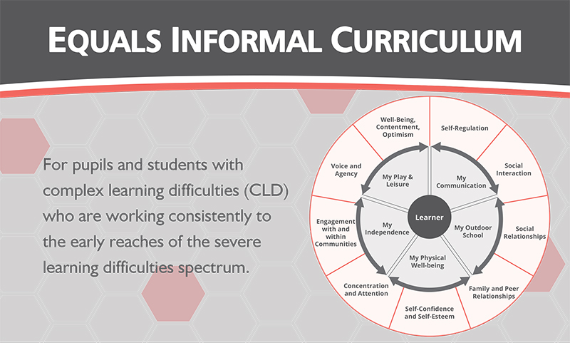
This means our learners are:
- Positively encouraged to be comfortable with activities and states of being that are important to them, as part of the process of being given opportunities to discover other activities and states of being that may become important to them.
- Free to like who and what they wish and be encouraged to learn how to express such preferences positively.
- Free to reject experiences and people not liked and encouraged to learn how to express such preferences positively.
- Positively encouraged to take total control of their own behaviour so that self-regulation, rather than being regulated by others, becomes a major part of their learning.
- Given constant opportunities to communicate positively and to have a voice and make choices that are listened to with preferences acted upon within the confines of a safe and secure environment. There may be times when voice and choice are denied, but these will only be in exceptional circumstances when the safety of the learner or those around the learner is in question.
- Always working towards EHCP long term outcomes and short-term targets.
Pathway 2: Semi-Formal Curriculum
The Pathway 2: Semi-Formal Curriculum pathway promotes what the children need rather than being constrained by National Curriculum subject areas. Teachers have the freedom to be creative and concentrate on individual needs with a focus on independence.
Pupils access their learning in a typically multi-sensory way, through curriculum areas rather than discrete subjects with all curriculum areas following a common topic theme, which is rotated termly, in order to reduce cognitive load, minimise transitions in learning and create a common context for learning which better suits the typical learning style of our Pathway 2 pupils.
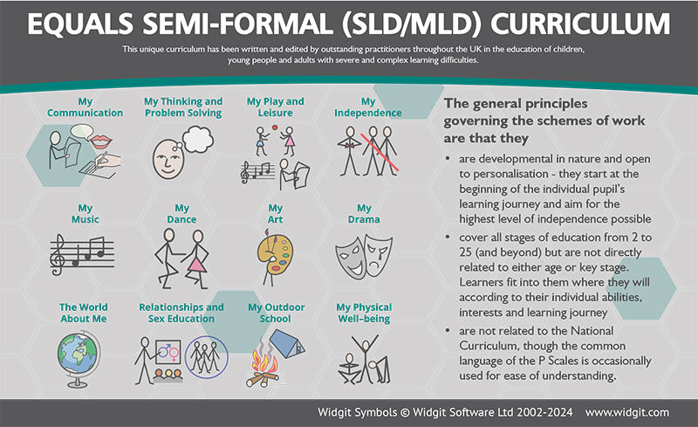
Curriculum areas are developmental in nature and open to personalisation – beginning of the start of an individual pupil’s learning journey and aiming for the highest level of independence possible.
This means our learners are:
- Free to develop early communication skills, focusing on pre-linguistic, early linguistic and attention skills.
- Therapy is integrated into the classroom and all input – SaLT, occupational therapy and teaching is as integrated and collaborative as possible.
- Given opportunities to support and develop emotional regulation and their level of arousal and sensory needs, anxieties and additional emotional needs are considered,
- Able to thrive in our school, a place where they feel happy, safe, and trusted.
Pathway 3: Formal Pathway
The Pathway 3: Formal Curriculum pathway is reflective of the Equals Formal curriculum, programmes of the National Curriculum and EYFS Development Matters.
Pathway 3, follows the Equals formal curriculum and is adapted to support pupils who may not be consistently working within the National Curriculum. It recognises those pupils working consistently and over time at below age-related expectations considering and recognising a number of reasons including but not exclusive to gaps in the knowledge and learning experience, low levels of engagement in learning, low attendance at school, previous negative experiences in education, and barriers identified within their EHCP.
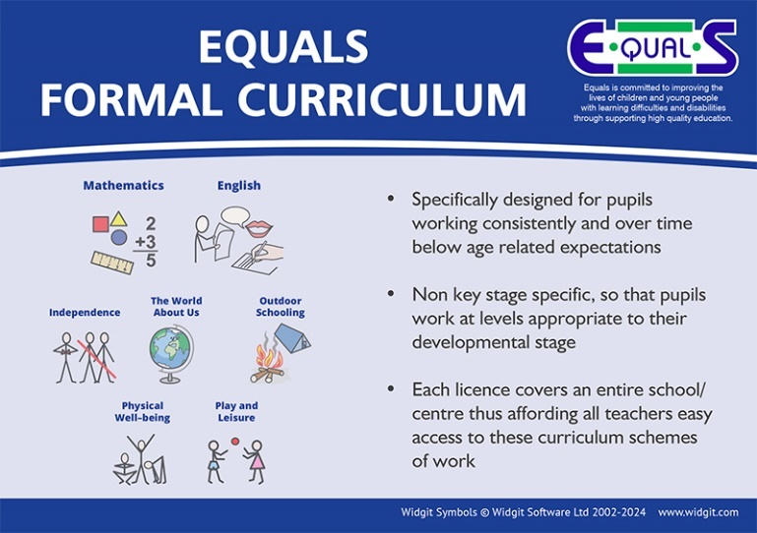
Pupils access areas of the national curriculum through a highly personalised approach that also supports the outcomes outlined in their EHCPs. Depending on individual needs, pupils may have specific elements of the national curriculum incorporated into their personalised targets. Alternatively, they may follow a reduced or adapted framework in one or more core subjects—such as English, Maths, or Science—to ensure accessibility and meaningful progress.
This means our learners:
- Benefit from personalised, relevant learning that helps them make meaningful progress at their own pace.
- Access learning that is tailored to each pupil.
- Will have specific parts of the National Curriculum integrated into their personal learning targets and may follow a simplified version of core subjects such as English, Maths, or Science.
- Are supported to achieve the best possible outcomes, both academically and in terms of their wider EHCP goals through a curriculum that truly reflects their needs.

Autism Friendly Curriculum:
Threaded within each pathway are our Autism friendly curriculum focus:
Communication  and  Interaction |  | Engaging in interaction  Making requests  Communicating information / commenting on events  Listening and understanding  Greetings  Conversations  Non-verbal communication
Social understanding  and  Relationships |  | Being with others  Interactive play  Positive relationships with supporting adults  Positive relationships and friendships (peers)  Group activities
Sensory processing |  | Understanding and expressing own sensory needs  Responding to sensory interventions  Increasing tolerance of sensory input  Managing own sensory needs
Interests, routines  and  processing |  | Coping with change  Transitions  Special interests  Problem solving and thinking skills
Emotional understanding  and  Self-awareness |  | Understanding and expressing own emotions  Managing emotions and behaviour  Understanding others’ emotions/ intentions  Self-awareness  Developing confidence and self-esteem
Learning  and  Engagement |  | Learning through play  Motivation and engagement  Organisation and independent learning  Understanding and following rules, routines and expectations  Evaluating own learning
Healthy living |  | Keeping Healthy  Personal Care  Relationships and Sex Education
Independence  and  Community participation |  | Independent Living  Personal Safety  Road Safety and Travel  Leisure

SMSC:
SMSC is immersed within the day to day operations of the school through the implementation of the school values. It is the expectation that pupils show an awareness and respect for diversity, take part in social opportunities, cultural opportunities and artistic opportunities.
The school’s SMSC programme is supported by a very diverse staff team who model behaviour that demonstrates British values. Staff are trained to challenge behaviours and opinions that are contrary to those of fundamental British Values. Pupils are encouraged to have a voice and develop respect for democracy through the school’s Student Council
At Bradford Beacon School we provide an education that provides pupils with opportunities to explore and develop their own moral values and beliefs, spiritual awareness, high standards of personal behaviour, a positive caring attitude towards other people, an understanding of their social and cultural traditions and an appreciation of the diversity and richness of other cultures. Throughout the curriculum, we encourage pupils to respect the fundamental British values of democracy, the rule of the law, individual liberty and mutual respect and tolerance of those with different faiths and beliefs.
As part of the wider SMSC curriculum, pupils are encouraged to act responsibly and to support their own and the wider community. The development of the pupils understanding of institutions such as Police, Fire, NHS, Post Office, Law and Courts etc along with daily living skills, independent skills, travel training and relationships are addressed through the school’s bespoke curriculum.
Our curriculum will:
- Promote mutual respect and tolerance.
- Promote individual liberty.
- Promote the rule of law.
- Ensure that everyone connected with the school is aware of British values and principles.
- Ensure that everyone connected with the school is aware of our own values and principles.
- Ensure a consistent approach to the delivery of SMSC issues.
- Ensure that a pupil’s education is set within a context that is meaningful and appropriate to their needs
- Ensure that pupils know what is expected of them and why.
- Give pupils a range of opportunities to reflect upon and discuss their beliefs, feelings and responses to personal experience.
- Enable pupils to develop an understanding of their individual and group identity.
- Enable pupils to begin to develop an understanding of their social and cultural environment, and an appreciation of the many cultures that now enrich our society.
- Give each pupil the opportunity to explore social and moral issues and develop a sense of social and moral responsibility.
Spiritual Development:
As a school we will provide learning opportunities that will support pupils to:
- Develop and sustain their self-esteem in their learning experience.
- Develop their capacity for independent thought.
- Foster their emotional life and express their feelings.
- Experience moments of stillness and reflection.
- Explore their beliefs, feelings, values and responses to personal experiences.
- Form and maintain worthwhile and satisfying relationships
- Reflect on, consider and celebrate the wonders and mysteries of life.
Social Development:
As a school we will promote opportunities that will support pupils to:
- Develop an understanding of their individual and group identity.
- Learn about helping others and making a positive difference in the school and wider community.
Cultural development:
As a school we will promote opportunities that will enable pupils to:
- Actively promote the value and richness of cultural diversity in Britain.
PSHE within the Curriculum:
PSHE is central to the development of the children in our school. It helps pupils to develop the knowledge, skills and understanding they need to live the most confident, productive, independent and healthy lives, appropriate for them as individuals. With collaboration among pupils, staff, and families we wish to create a strong sense of community, supporting pupils in building relationships and social skills.
Enabling self-awareness and an understanding of their community and the world they live in. It will support reducing and/or where achievable, remove barriers to learning by providing an education that promotes positive relationships and supports pupils reaching their full potential. It develops key concepts, language skills, strategies and understanding to enable pupils to make positive lifestyle choices now and in their future and an understanding of relationships that will affect them throughout life.
Our curriculum promotes both the present and future wellbeing of our pupils using the PSHE Association Planning Framework for Pupils with SEND. We strive for our pupils to maintain positive relationships with adults, feel valued and where those who are most vulnerable are identified and supported. Bradford Beacon School provides opportunities for the children, where appropriate, to make decisions about their lives. PSHE areas is also a vehicle for addressing both multi-cultural and gender issues and ensuring equal opportunities.
We promote Outcomes First Group Ask, Accept, Develop Autism strategy, where children will be feel listened to and can demonstrate their ability to take responsibility for their decisions.
Equal Opportunities:
We promote the needs and interest of all pupils irrespective of gender, culture, ability or aptitude. Teaching strategies will consider the ability, age, readiness and cultural backgrounds of the pupils, to ensure that all can access our curriculum pathways and provision. We promote social learning and expect our pupils to show a high regard for the needs of others.

Protected characteristics:
The Equality Act uses the term “protected characteristics” to refer to aspects of a person’s identity. Treating a person less favourably because they have one or more of these characteristics would be unlawful. The protected characteristics are:
- Age.
- Disability.
- Gender reassignment.
- Marriage and civil partnership.
- Pregnancy and maternity.
- Race.
- Religion or belief.
- Sex.
- Sexual orientation.
British Values:
British values are promoted in so much of what we do. Modern British values are integral to our school vision and ethos and underpin our daily school lives. As well as actively promoting British values in school, the opposite also applies: we would actively challenge pupils, staff or professionals expressing opinions contrary to fundamental British values, including ‘extremist’ views through the PREVENT strategy.
Non-partisan views:
Our curriculum is designed to be non-partisan and the OFG group reminds those with an influence over our pupils to maintain a non-partisan approach at all times during curriculum delivery.
Careers:
At Bradford Beacon School, career discussions will be carefully woven into different curriculum areas, relating them to real-world applications. Conversation about careers, where appropriate, will be ongoing, adapting content as pupils grow and their understanding deepens and develops. By introducing career concepts early and building upon these progressively, we can help our pupils understand the world of work and inspire them to explore their interests and aspirations. Careers will be introduced by;
- Using storytelling, books, toys, role play and visits to explore a diverse range of careers
- Play-Based Learning -themed play areas (e.g., a doctor's office, grocery store) to allow children to explore different roles through imaginative play.
- Language and Communication- We encourage discussions about what different jobs entail, using simple language and visuals to make connections.
- Job Exploration Activities.
- Creation of "career corners” in classrooms; where appropriate.
- Local visits observe different workplaces and meet professionals.
- Guest Speakers- discussion of their careers and how they help the community, making it relatable for pupils.
- Career Days- themed days where pupils can dress up as professionals and learn about different jobs
- Skill Development- focus on skills relevant to various careers, such as teamwork, problem-solving, and communication.
- Reflection and Discussion- interests and aspirations, helping pupils connect their hobbies and skills to potential career paths.
Behaviour for Learning:
Pupils' access to the curriculum is underpinned by promoting positive behaviour through a supportive and consistent approach that is based on an understanding of our children and young people’s individual needs. Bradford Beacon has a neurodivergence affirming, trauma informed, needs-led approach that encourages positive behaviour by proactively recognising and flexibly supporting our pupils’ holistic individual needs. Staff are trained to always apply this approach in practice and support our pupils consistently and fairly, developing positive, respectful relationships with them.
Organising the school into small, accessible areas of learning which are nurturing in nature creates a safe and positive environment for pupils.
There is a very strong home/school liaison system. A strong relationship between home and school facilitates sharing of information and consistency, enabling better access to the curriculum. There is an achievement assembly at the end of each week and pupils are given certificates in recognition of their achievements and successes.
Daily staff briefings enable the whole staff team to have the opportunity to share information and good practice. The constant flow of information equips staff with a range of strategies, making them more proactive than reactive in their approaches and equipping them with a more in-depth understanding of pupils.
Comprehensive Planning:
Through implementing the school’s curriculum policies and practices, we ensure that teachers provide a variety of relevant experiences for our pupils. This is done through careful planning of the curriculum. Teachers plan from a wider curriculum map, identifying pathways and are expected to have medium term planning for the classes they teach, which clearly outlines differentiation for the individual needs of pupils. The teacher will ensure that outcomes are clearly stated on their planning to inform others of where the pupil is expected to reach
Engaging lessons:
Through a wide range of strategies, teachers prioritise teaching that encourages pupil engagement, thought, question, creativity and teamwork. Pupils play an active role in designing their own curriculum which has a positive impact on engaging in learning. Lessons are personalised based on pupils’ interests and their preferred learning styles which are taken from pupils’ communication profiles. Teachers' creativity relates lessons to everyday life scenarios and makes pupils aware of the ‘big picture’ by linking their learning to their aspirations and their ambitions.
Reflective of the needs of pupils, lessons may be broken down into small manageable learning experiences with short breaks in between and are personalised to individual pupils. Activities for breaks during lessons have pre-planned structured choice activities. Teachers use the other adults in the room to create a positive climate for learning and to help pupils engage. Teaching assistants are always used as a learning resource.
Curriculum Impact
Assessment, recording and reporting:
At Bradford Beacon, we believe that every pupil is unique and deserves an education tailored to their individual needs. To ensure that our pupils receive the support they require, we track and measure progress and learning reflective of each pupils identified curriculum pathway, and the needs identified within their EHCP.
Diagnostic, formative and evaluative assessment is used to make judgments about the achievements of a pupil and therefore contribute to future planning.
All pupils are assessed on entry. A multidisciplinary team including teachers, Occupational Therapist, and Speech and Language Therapist use cognitive assessments and identified summary of special educational needs within pupil’s EHCP’s, are used to determine each pupil's starting point. Additional factors, such as social-emotional needs, learning profiles; including ‘spiky’ profiles and language comprehension are also considered. Pupils are then baselined on the Evidence for Learning (EFL) platform, which helps set initial targets and identify interventions that may need to be in place for pupils to extend their learning. This process typically takes half a term.
Teachers plan from a wider curriculum map, identifying the appropriate curriculum pathway and are expected to have medium term planning for the classes they teach, which clearly outlines differentiation for the individual needs of pupils. The teacher will ensure that outcomes are clearly stated on their planning to inform others of where the pupil is expected to reach. Teachers ensure they are making ongoing judgements of learning.
After baselining, a personalised learning pathway is developed, including Personalised Learning Intentions (PLIs). Challenging, smaller step targets stem from the EHCP and curriculum outcomes are also measured within the PLIs. PLIs are updated termly and inform medium-term planning and day to day teaching.
Our staff use a range of assessment tools and strategies to gather ongoing detailed information about each pupil’s strengths, challenges, and progress. Judgements are based on evidence from more than one source, such as teacher observations, TA observation, annotation and feedback, pupils’ work across the curriculum and feedback from all other professionals working with individual pupil’s e.g. therapeutic input.
PSHE underpins our curriculum and is closely aligned with each pupil’s EHCP outcomes and termly targets. It serves as a continuous, embedded thread running through all curriculum pathways and areas of learning, ensuring that personal development remains central to every pupil’s learning pathway.
Evidence is gathered termly through Evidence for Learning (EFL) platform, including narrative feedback and next steps. This builds a clear picture of each pupil’s learning journey. By utilising this data, we can create learning programmes and PLIs that address specific needs, set realistic targets, and monitor progress effectively.

Through our robust assessment framework, we strive to foster a positive and inclusive learning environment that empowers our pupils to reach their full potential, evidenced by:
- Formative and summative assessments throughout termly themes with learners encouraged to evaluate their own progress, where appropriate.
- Ongoing evaluation of EHCP Outcomes, short term targets and behaviour targets.
- Medium term planning formats and quality assurance processes.
- Regular data points during the year, on a termly basis to evidence progress and to identify areas of development and next steps.
- Termly progress report and consultation evening with parents and carers at the end of each term.
- A full annual report on progress including feedback from therapeutic input, where appropriate.
- EHCP aims and outcomes, which are reviewed and set at the Annual Review/
- RBA and EYFS profile assessments at the beginning and end of reception year, where it is deemed appropriate.

Assessment Tools and Strategies
EYFS | Pathway 1  Informal | Pathway 2  Semi-Formal | Pathway 3  Formal
RBA & EYFS profile assessments  Rocket Phonics  Accelerated Reader  EFL  PLIs | Rocket Phonics  Accelerated Reader  EFL – Progression Documents  PLIs | Rocket Phonics  Accelerated Reader  EFL – Progression Documents  PLIs | Rocket Phonics  Accelerated Reader  EFL – Progression Documents  PLIs
EHCP outcomes and termly short-term targets are a flowing thread throughout all curriculum pathways and areas of learning; Evidence for Learning (EFL)

Progress Rationale:
Progress is not only seen vertically at Bradford Beacon School; achieving new skills but also laterally, by developing fluency, confidence and independence with existing skills. Maintaining and applying skills over time is key to ensuring learning is deep, meaningful, and transferable. The expected rate of progress for each individual pupil is set through a multi-disciplinary team to ensure our pupils are achieving to their full potential, taking in to account individual learning needs and diagnosis. Progress is identified using the following scale:
Progress Scale | Record as | Description | Key Characteristics
Not yet developed | NYD | Skill or behaviour is not present or is only beginning to emerge. Requires a high level of prompting and adult support. | - Skill or behaviour rarely or never seen  - Heavy adult support and prompt  - Emergent or absent
Developing | D | There is some evidence of progress. Skill may be demonstrated with a lower level of prompt or support. May occur spontaneously but not consistently. | - Occasional spontaneous use  - Less support and prompt needed but still required  - Not yet embedded or consistent
Established | E | The skill is used frequently and maintained over time. Mostly demonstrated independently and spontaneously, with only occasional adult support. | - Regular use  - Mostly independent  - Some support and prompt may be needed occasionally
Generalised | G | Skill is consistently used across different activities, settings, and with various people. Fully independent and unprompted. | - Consistent independent use  - Applied in diverse contexts  - No prompting required

Quality Assurance:
The quality of education provided to pupils at Bradford Beacon School is monitored and evaluated by a robust quality assurance process which includes:
- Termly lesson observations – Teachers and TAs
- Termly pupil progress meetings
- Termly supervisions for all teaching and teaching assistant staff
- Work and book scrutiny, including marking and assessment (where appropriate), and ‘deep dive’ activities.
- Moderation with other teachers using specific learning pathways and subject leaders from other schools within OFG.
- EFL data analysis
- Learning walks with visiting staff, including Clinical colleagues, Quality team members, and governors.

Reporting to Parents & Carers:
The primary means of reporting on progress to parents is via the Annual Review process, in which detailed feedback is given in relation to the short and long-term objectives identified in Section E of their child’s Education, Health and Care Plan.
Parents and carers are also kept informed of the breadth, depth and quality of the education via:
- Parents Evenings and Informal parent engagement events
- School newsletters; weekly and termly
- Regular school to home updates and messages
- Termly and End of year report
- School website
This policy will be reviewed yearly to reflect the ever-changing needs and presentation of our cohort and is to be read in conjunction with:
- Behaviour Policy (Person-Centred Neurodivergence Affirming)
- Accessibility Plan
- Equal Opportunities Policy
- E-Safety Policy
- Special Educational Needs and Inclusion
- SMSC and British Values
- Assessment
- Teaching and Learning

