

Careers

Overview
Bradford Beacon School


Careers and Employability Overview – Bradford Beacon School

Careers
At Bradford Beacon School children will be introduced to careers by;
- Using storytelling, books, toys, role play and visits to explore a diverse range of careers
- Play-Based Learning -themed play areas (e.g., a doctor's office, grocery store) to allow children to explore different roles through imaginative play.
- Language and Communication- We encourage discussions about what different jobs entail, using simple language and visuals to make connections.
- Job Exploration Activities
- Creation of "career corners” in classrooms (where appropriate)
- Local visits observe different workplaces and meet professionals.
- Guest Speakers- discussion of their careers and how they help the community, making it relatable for the children.
- Career Days- themed days where students can dress up as professionals and learn about different jobs
- Skill Development- focus on skills relevant to various careers, such as teamwork, problem-solving, and communication.
- Reflection and Discussion- interests and aspirations, helping children connect their hobbies and skills to potential career paths.

General Strategies
We weave career discussions into different curriculum areas, relating them to real-world applications. Conversation about careers, where appropriate, will be ongoing, adapting content as children grow and their understanding deepens. By introducing career concepts early here at Bradford Beacon School, and building on them progressively, we can help children understand the world of work and inspire them to explore their interests and aspirations.

Impartial Careers Advisor:
We have established a careers guidance service, designed to meet the specific needs of our pupils.
The new Futures Team is made up of ten highly trained Regional Futures Advisors. Each of them has a Level 6 or 7 qualification in Careers Guidance or is a supported apprentice, complemented by specialist expertise in working with young people who have additional or complex needs.
The team is presently for September constructing a bespoke Special Educational Needs (SEND) Careers curriculum, which will revolutionise guidance by offering students the opportunity to achieve a qualification whilst preparing for their future.

The Futures Team
Each Advisor covers a distinct region of the UK, with responsibility for a maximum of 10 schools each. The offering includes:
- Interaction with every student annually, to ensure that each young person’s voice is heard.
- Support in identifying and sourcing meaningful work experience opportunities.
- School and staff support through training, assessment, consultation and implementation of strategy and provision.
- Annual audits of the provision, to ensure each school is meeting and complying with the Careers Development Institute and Gatsby benchmarks.

Our advisors will also be a consistent and accessible point of contact for both students and school colleagues.
The Futures Team is able to offer more 1:1 time with students, and to make that time more meaningful and effective. Our approach is holistic and comprehensive, looking beyond careers alone, to consider hobbies and independent skills and interest. By understanding how best to engage the young person in planning for their own future, our advisors will be able to identify opportunities that will really inspire students.
In addition to this, the Futures Team will work with students to obtain exciting and impactful work experience opportunities that is also at times supported by the Dream Big Foundation. It is our aim to ensure that every student is able to pursue their vocational passions, regardless of how unique the goal.

Many of these opportunities have been tailored to accommodate the individual needs of our young people. We are able to provide 1:1 support, in a comfortable setting, to allow students to really gain the best from their experience.
By meeting with each student within a primary setting, we are able to spend as much time and energy as possible on finding the right opportunity for them to Dream Big.

Bradford Beacon School have the support of impartial advisor Kelly Guthery. Kelly is a RCDP Level 7 advisor.
Kelly will also monitor all aspects of Quality Assurance to ensure compliance.
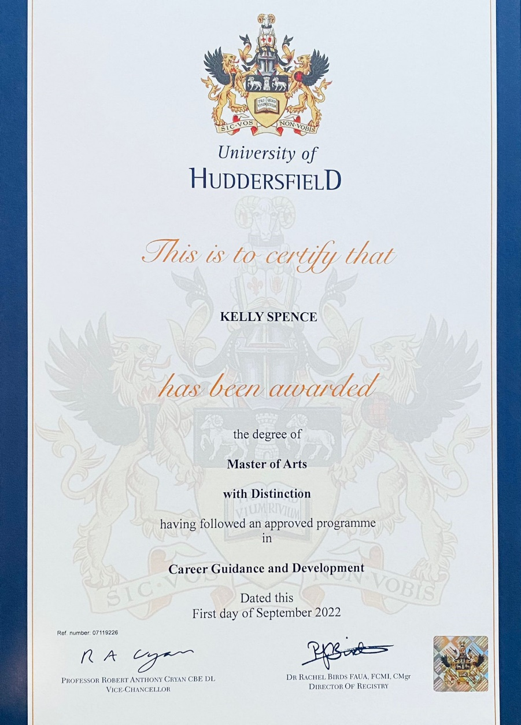
Curriculum:
The school has access to the group’s primary careers curriculum. This maps to the CDI’s aim and objectives and ensures progression throughout the school in preparation for mandatory elements with KS3. The curriculum encourages assessment through sensory AQA unit awards allowing learners to achieve. The curriculum is available to view and will be finalised in print in September.

Work Experience:
The school will be supported to offer where appropriate access to external work experiences in areas suited to the learners that promote life skills. Internal work experience opportunities will also be offered in areas such as tutor shadowing to build independence and confidence.
Guest Speakers
In readiness for Provider Access in KS3, learners where appropriate will begin to meet with guest speakers and visitors who can support in exploration of the wider world.

