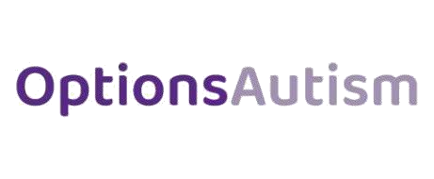

Bradford Beacon School Pupil Premium Statement

As an independent special school, placement fees acknowledge Pupil Premium payments where applicable.

No records for the separate spending of Pupil Premium are in place due to the extensive offer and content of placement designed to improve educational and personal outcomes.

October 2023

